**Post-Accident Report Advisory Committee**

**Supporting Documentation**

**NHTSA Police Accident Reports (PAR) Repository** (note that some PARs may be out of date): <http://www.nhtsa.gov/nhtsa/stateCatalog/stateData.html>

* Ohio’s PAR (Vehicle Form – Vehicle Type): <http://www.nhtsa.gov/nhtsa/stateCatalog/states/oh/docs/OH-1_rev1_2012.pdf>

**FMCSA Crash Data Elements:** <https://ask.fmcsa.dot.gov/app/mcmiscatalog/d_crash3>

**Visor Cards containing FMCSA crash reporting assistance:** <https://www.fmcsa.dot.gov/regulations/enforcement/visor-cards-law-enforcement>

* [Blue - Truck and Bus Crashes Reportable to FMCSA](https://www.fmcsa.dot.gov/regulations/enforcement/truck-and-bus-crashes-reportable-fmcsa-blue-visor-card)
* [Red - How to Find the Responsible Carrier and Correct U.S. DOT Number](https://www.fmcsa.dot.gov/regulations/enforcement/how-find-responsible-carrier-and-correct-us-dot-number-red-visor-card)
* [Green - Vehicle Configuration & Cargo Body Type](https://www.fmcsa.dot.gov/regulations/enforcement/vehicle-configuration-green-visor-card)
* [Yellow - Nine Classes of Hazardous Materials (HM) & Reporting HM Information](https://www.fmcsa.dot.gov/regulations/enforcement/nine-classes-hazardous-materials-yellow-visor-card)
* [Orange - Commercial Driver's License (CDL)](https://www.fmcsa.dot.gov/regulations/enforcement/commercial-drivers-license-endorcements-orange-visor-card)

**Federal Motor Carrier Safety Regulations: Definitions (Title 49 Code of Federal Regulations, Part 390.5):**

<http://www.ecfr.gov/cgi-bin/retrieveECFR?gp=1&ty=HTML&h=L&mc=true&=PART&n=pt49.5.390#se49.5.390_15>

**Model Minimum Uniform Crash Criteria data elements (version 4):**

<http://www.mmucctraining.us/>

**Attachment A: FMCSA/MCMIS Crash Data Elements**

Data Elements – edited from <https://ask.fmcsa.dot.gov/app/mcmiscatalog/d_crash3>

# MCMIS Catalog and Documentation

## Crash File - Data Element Definitions

Note: Fields in Place Since 2014. Last Updated: 2014

**CRASH MASTER TABLE**

|  |  |
| --- | --- |
| **Data Element** | **Definition** |
| **CRASH ID** (CRASH_ID) | [Max field length 8] This is a unique identifying number assigned to a crash record. |
| **REPORT STATE** (REPORT_STATE) | [Max field length 2] The state that reported the crash. |
| **REPORT NUMBER** (REPORT_NUMBER) | [Max field length 12] The unique report number is designated by the state. The only requirements are that it starts with the two-letter state code and is followed by 10 characters. |
| **REPORT DATE** (REPORT_DATE) | [Max field length 8] The date on which the crash occurred. (YYYYMMDD) |
| **REPORT TIME** (REPORT_TIME) | [Max field length 4] The military time at which the crash occurred. |
| **REPORT SEQUENCE NUMBER** (REPORT_SEQ_NO) | [Max field length 2] This field is used to identify the vehicles in a multiple vehicle crash. If only one commercial motor vehicle was involved the value will be 1. For each additional vehicle involved it will be increased by 1. |
| **CENSUS NUMBER** (DOT_NUMBER) | [Max field length 8] This is the number assigned by MCMIS to a census record. It is sometimes referred to as the USDOT number. Each motor carrier should have only one active census number. The census number has no internal coded structure. Numbers are issued sequentially as carriers are added to the system. |
| **LOCATION** (LOCATION) | [Max field length 50] The street address or highway number where the crash occurred. |
| **CITY CODE** (CITY_CODE) | [Max field length 5] The 5-digit code for the municipality (city or township) in which the crash occurred as implemented by FIPS PUB 55-3. |
| **CITY** (CITY) | [Max field length 25] The name of the municipality (city or township) in which the crash occurred. |
| **STATE** (STATE) | [Max field length 2] The state/district in which the crash occurred. |
| **COUNTY CODE** (COUNTY_CODE) | [Max field length 3] The 3-digit Worldwide Geographical Code for the county in which the crash occurred. FIPS PUB 6-4 |
| **TRUCK/BUS INDICATOR** (TRUCK_BUS_IND) | [Max field length 1] Indication of whether the vehicle involved in the crash was a truck (T) or bus (B). |
| **TRAFFICWAY** (TRAFFICWAY_ID) | [Max field length 8] The degree of trafficway division at the place of the crash.  1 = Two-way, not divided  2 = Two-way, divided, unprotected median  3 = Two-way, divided, positive median barrier  4 = One-way, not divided  98 = Not reported  99 = Unknown |
| **ROAD ACCESS CONTROL** (ACCESS_CONTROL_ID) | [Max field length 8] The degree that access to abutting land, light, air, or view in connection with highway is fully controlled by public authority.  1 = Full Access Control 2 = Partial Access Control 3 = No Access Control |
| **ROAD SURFACE CONDITION** (ROAD_SURFACE_CONDITION_ID) | [Max field length 8] The condition that affected traction on the road surface at the time and location of the crash.  1 = Dry  2 = Wet  3 = Water (standing, moving)  4 = Snow  5 = Slush  6 = Ice  7 = Sand, Mud, Dirt, Oil or Gravel  8 = Other  9 = Unknown or Blank |
| **CARGO BODY TYPE** (CARGO_BODY_TYPE_ID) | [Max field length 8] The cargo body type of the motor vehicle.  1 = Bus (seats for 9-15 people, including driver) 2 = Bus (seats more than 15 people, including driver) 3 = Van/Enclosed Box 4 = Cargo Tank 5 = Flatbed 6 = Dump 7 = Concrete Mixer 8 = Auto Transporter 9 = Garbage/Refuse 10 = Grain, chips, gravel 11 = Pole 12 = Not applicable 13 = Intermodal 14 = Logging 15 = Vehicle Towing another Vehicle 98 = Other |
| **GROSS VEHICLE WEIGHT RATING ID** (GVW_RATING_ID) | [Max field length 8] Weight rating of the power unit of the vehicle.  1 = 10,000 lbs or less  2 = 10,001 lbs. – 26,000 lbs.  3 = 26,001 or greater  9 = Missing/Unknown |
| **VEHICLE IDENTIFICATION NUMBER** (VEHICLE_IDENTIFICATION_NUMBER) | [Max field length 17] The Vehicle Identification Number(VIN) of the motor vehicle. The VIN is a unique combination of alphanumeric characters formulated by the manufacturer. |
| **VEHICLE LICENSE NUMBER** (VEHICLE_LICENSE_NUMBER) | [Max field length 9] The numeric, alphanumeric, or alphabetic character, exactly as displayed, on the plate or tag affixed to the motor vehicle. |
| **VEHICLE LICENSE STATE** (VEHICLE_LIC_STATE) | [Max field length 2] The state/district issuing the license plate of the motor vehicle. ([See Appendix A](https://ask.fmcsa.dot.gov/euf/assets/mcmiscatalog/states.html)[Opens in New Window]) |
| **HAZARDOUS MATERIALS PLACARDS** (VEHICLE_HAZMAT_PLACARD) | [Max field length 1] Indication of whether the motor carrier had a hazardous materials placard. |
| **WEATHER CONDITION** (WEATHER_CONDITION_ID) | [Max field length 8] The predominant weather condition at the time and place of the crash.  1 = No Adverse Condition 2 = Rain 3 = Sleet, Hail 4 = Snow 5 = Fog 6 = Blowing Sand, Soil, Dirt, or Snow 7 = Severe Crosswinds 8 = Other 9 = Unknown or Blank |
| **VEHICLE CONFIGURATION** (VEHICLE_CONFIGURATION_ID) | [Max field length 8] The configuration of the motor vehicle.  1 = Passenger Car (Only if Vehicle displays HM Placard)  2 = Light Truck (Only if Vehicle displays HM Placard)  3 = Bus (Seats for 9-15 People, Including Driver)  4 = Bus (Seats for > 15 People, Including Driver)  5 = Single-Unit Truck (2-Axle, 6-Tire)  6 = Single-Unit Truck (3 or More Axles)  7 = Truck/Trailer  8 = Truck Tractor (Bobtail)  9 = Tractor/Semitrailer  10 = Tractor/Double  11 = Tractor/Triple  99 = Unknown Heavy Truck > 10000 lbs, Cannot Classify |
| **LIGHT CONDITION** (LIGHT_CONDITION_ID) | [Max field length 8] Light condition at the time and place of the crash.  1 = Daylight  2 = Dark-Not Lighted  3 = Dark-Lighted  4 = Dark-Unknown Roadway Lighting  5 = Dawn  6 = Dusk  8 = Other  9 = Unknown or Blank |
| **HAZMAT RELEASED** (HAZMAT_RELEASED) | [Max field length 1] Indicates whether or not Hazardous Material was released as a result of the crash. |
| **REPORTING AGENCY** (AGENCY) | [Max field length 35] The agency that was responsible for investigating and reporting the crash. |
| **OFFICER BADGE NUMBER** (OFFICER_BADGE) | [Max field length 5] The badge number of the officer completing the police crash report. |
| **VEHICLES IN ACCIDENT** (VEHICLES_IN_ACCIDENT) | [Max field length 2] The total number of vehicles or vehicle combinations involved in the crash. This greater than zero number includes all trucks, buses, and other vehicles, such as cars and pedalcycles, involved in the crash. |
| **FATALITIES** (FATALITIES) | [Max field length 3] Number of persons killed inside or outside a vehicle at the scene of the crash. |
| **INJURIES** (INJURIES) | [Max field length 3] Number of persons injured inside or outside a vehicle at the scene of the crash who were transported to a medical facility for immediate medical attention. |
| **TOW AWAY** (TOW_AWAY) | [Max field length 1] Indication of whether one or more motor vehicles were disabled and transported away from the scene by a tow truck or another vehicle. |
| **FEDERALLY RECORDABLE** (FEDERAL_RECORDABLE) | [Max field length 1] Indication of whether the crash was Federally Recordable. A "recordable" crash has occurred when at least one person dies, or at least one person experiences bodily injury which requires immediate medical treatment away from the scene of the crash, or a vehicle is towed away. |

**CRASH CARRIER TABLE**

|  |  |
| --- | --- |
| **Data Element** | **Definition** |
| **CARRIER NAME** (CRASH_CARRIER_NAME) | [Max field length 120] Name of the individual, partnership, or corporation responsible for the transportation of goods or persons. |
| **CARRIER STREET** (CRASH_CARRIER_STREET) | [Max field length 50] The street address of the principal place of business of the carrier reported under CARRIER NAME. |
| **CARRIER CITY** (CRASH_CARRIER_CITY) | [Max field length 25] The name of the municipality (city or township) of the principal place of business of the carrier reported under CARRIER NAME. |
| **CARRIER CITY CODE** (CRASH_CARRIER_CITY_CODE) | [Max field length 5] Can be blank |
| **CARRIER STATE** (CRASH_CARRIER_STATE) | [Max field length 2] State/District/Province of the principal place of business of the carrier reported under CARRIER NAME. |
| **CARRIER ZIP CODE** (CRASH_CARRIER_ZIP_CODE) | [Max field length 10] ZIP code of the principal place of business of the carrier reported under CARRIER NAME. |
| **COLONIA** (CRASH_COLONIA) | [Max field length 25] This field specifies the carrier's Mexican Colonia. (For Mexican domiciled carriers.) |
| **PREFIX** (PREFIX) | [Max field length 2] Docket Number PREFIX (usually MC, MX, or FF). |
| **DOCKET NUMBER** (DOCKET_NUMBER) | [Max field length 8] The docket number (MC, MX, or FF number) assigned by FMCSA or the former Interstate Commerce Commission to the carrier reported under CARRIER NAME. Formerly known as the ICC number. |
| **INTERSTATE** (CRASH_CARRIER_INTERSTATE) | [Max field length 1] Indication as to whether the motor carrier is: Intrastate (0), Interstate(1), or Non-Motor Carrier(2). |
| **STATE NUMBER** (STATE_NUMBER) | [Max field length 12] State number issued by the Public Utility Commission, Public Service Commission, or other state agency to the carrier reported under CARRIER NAME. |
| **STATE ISSUING NUMBER** (STATE_ISSUING_NUMBER) | [Max field length 2] State/District that issued the state census number to the carrier reported under CARRIER NAME. ([See Appendix A](https://ask.fmcsa.dot.gov/euf/assets/mcmiscatalog/states.html) [Opens in New Window]) |

**CRASH EVENT TABLE**

|  |  |
| --- | --- |
| **Data Element** | **Definition** |
| **SEQUENCE NUMBER** (SEQ_NO) | [Max field length 1] Numeric code indicating the sequence of events. |
| **EVENT ID** (EVENT_ID) | [Max field length 8] Indicates the type of event.  1 = Non collision ran off road 2 = Non collision jackknife 3 = Non collision overturn (rollover) 4 = Non collision downhill runaway 5 = Non collision cargo loss or shift 6 = Non collision explosion or fire 7 = Non collision separation of units 8 = Non collision cross median/centerline 9 = Non collision equipment failure (brake failure, blown tires, etc.) 10 = Non collision other 11 = Non collision unknown 12 = Collision involving pedestrian 13 = Collision involving motor vehicle in transport  14 = Collision involving parked motor vehicle 15 = Collision involving train 16 = Collision involving pedalcycle 17 = Collision involving animal 18 = Collision involving fixed object 19 = Collision with work zone maintenance equipment 20 = Collision with other movable object (Substitutes for previous "Collision involving other object") 21 = Collision with unknown movable object  98 = Other |
| **EVENT OTHER DECSCRIPTION** (EVENT_OTHER_DESC) | [Max field length 50] Descriptive field to define events other than those indicated on EVENT_ID. |

**CRASH DRIVER TABLE**

|  |  |
| --- | --- |
| **Data Element** | **Definition** |
| **DRIVER LAST NAME** (DRIVER_LAST_NAME) | [Max field length 20] The last name of the driver of the vehicle. |
| **DRIVER FIRST NAME** (DRIVER_FIRST_NAME) | [Max field length 20] The first name of the driver of the vehicle. |
| **DRIVER MIDDLE INITIAL** (DRIVER _MI) | [Max field length 1] The middle initial of the driver of the vehicle. |
| **DRIVER DATE OF BIRTH** (DRIVER_DATE_OF_BIRTH) | [Max field length 8] The date of birth of the driver. (YYYYMMDD) |
| **DRIVER LICENSE STATE** (DRIVER_LICENSE_STATE) | [Max field length 2] The license state/district/province of the driver. |
| **DRIVER LICENSE NUMBER** (DRIVER_LICENSE_NUMBER) | [Max field length 25] The driver's license number. |
| **VALID DRIVERS LICENSE** (VALID_DRIVER_LICENSE_FLAG) | [Max field length 1] Indicates whether or not the driver's license is valid. |
| **DRIVER LICENSE CLASS** (DRIVER_LICENSE_CLASS_ID) | [Max field length 8] Letter corresponds to Class A, B, C, D, M, or blank. |
| **CITATION ISSUED** (CITATION_ISSUED_CODE_ID) | [Max field length 8] Y = Yes, N = No, P = Pending, U = Unknown |

**Attachment B: Vehicle Configuration/Cargo Body Type Visor Card**

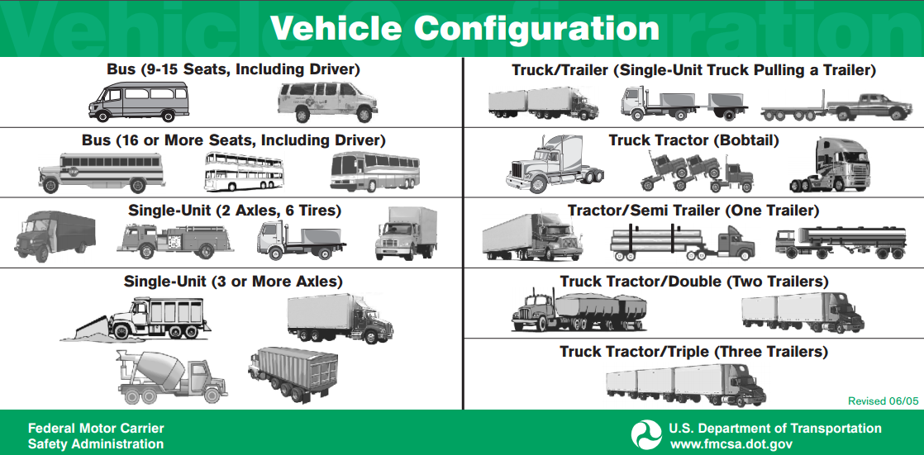

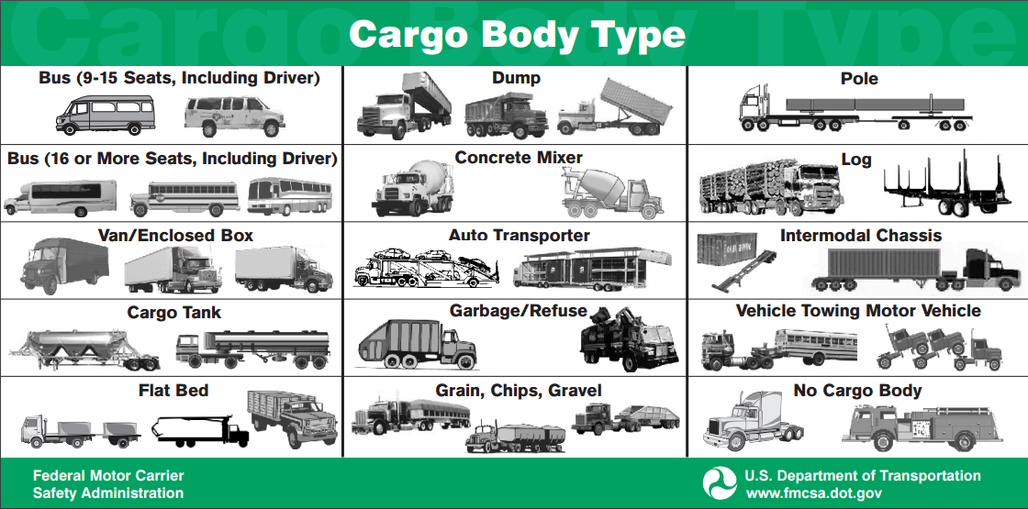

**Attached C – State Crash Form examples:**

Ohio – Vehicle Form:

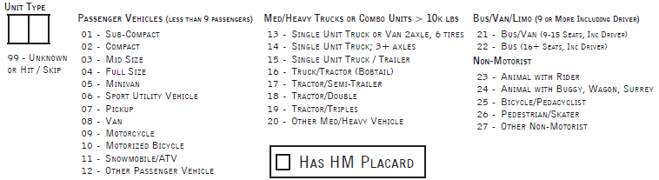

**Attachment D - Federal Motor Carrier Safety Regulations Definitions**

Title 40, Code of Federal Regulations, Part 390.5

<https://www.fmcsa.dot.gov/regulations/title49/section/390.5>

**Commercial motor vehicle** means any self-propelled or towed motor vehicle used on a highway in interstate commerce to transport passengers or property when the vehicle—

(1) Has a gross vehicle weight rating or gross combination weight rating, or gross vehicle weight or gross combination weight, of 4,536 kg (10,001 pounds) or more, whichever is greater; or

(2) Is designed or used to transport more than 8 passengers (including the driver) for compensation; or

(3) Is designed or used to transport more than 15 passengers, including the driver, and is not used to transport passengers for compensation; or

(4) Is used in transporting material found by the Secretary of Transportation to be hazardous under 49 U.S.C. 5103 and transported in a quantity requiring placarding under regulations prescribed by the Secretary under 49 CFR, subtitle B, chapter I, subchapter C.

**Gross combination weight rating (GCWR)** is the greater of:

(1) A value specified by the manufacturer of the power unit, if such value is displayed on the Federal Motor Vehicle Safety Standard (FMVSS) certification label required by the National Highway Traffic Safety Administration, or

(2) The sum of the gross vehicle weight ratings (GVWRs) or the gross vehicle weights (GVWs) of the power unit and the towed unit(s), or any combination thereof, that produces the highest value. Exception: The GCWR of the power unit will not be used to define a commercial motor vehicle when the power unit is not towing another vehicle.

**Gross vehicle weight rating (GVWR)** means the value specified by the manufacturer as the loaded weight of a single motor vehicle.

**Attachment E: Model Minimum Uniform Crash Criteria data elements (version 4)**

Source: <http://www.mmucctraining.us/index.aspx>

**Crash Data Elements:**

C1 Case Identifier

C2 Crash Classification

C3 Crash Date and Time

C4 Crash County

C5 Crash City/Place (political jurisdiction)

C6 Crash Location

C7 First Harmful Event

C8 Location of First Harmful Event Relative to the Trafficway

C9 Manner of Crash / Collision Impact

C10 Source of Information

C11 Weather Conditions

C12 Light Condition

C13 Roadway Surface Condition

C14 Contributing Circumstances, Environment

C15 Contributing Circumstances, Road

C16 Relation to Junction

C17 Type of Intersection

C18 School Bus-Related

C19 Work Zone - Related (Construction/Maintenance/Utility)

**Vehicle Data Elements:**

V1 Vehicle Identification Number (VIN)

V2 Motor Vehicle Unit Type and Number

V3 Motor Vehicle Registration State and Year

V4 Motor Vehicle License Plate Number

V5 Motor Vehicle Make

V6 Motor Vehicle Model Year

V7 Motor Vehicle Model

V8 Motor Vehicle Body Type Category

V9 Total Occupants in Motor Vehicle

V10 Special Function of Motor Vehicle in Transport

V11 Emergency Motor Vehicle Use

V12 Motor Vehicle Posted/Statutory Speed Limit

V13 Direction of Travel Before Crash

V14 Trafficway Description

V15 Total Lanes in Roadway

V16 Roadway Alignment and Grade

V17 Traffic Control Device Type

V18 Motor Vehicle Maneuver/Action

V19 Vehicle Damage

V20 Sequence of Events

V21 Most Harmful Event for this Motor Vehicle

V22 Bus Use

V23 Hit and Run

V24 Towed Due to Disabling Damage

V25 Contributing Circumstances, Motor Vehicle

V26 Motor Carrier Identification**

V27 Gross Vehicle Weight Rating / Gross Combination Weight Rating**

V28 Vehicle Configuration**

V29 Cargo Body Type**

V30 Hazardous Materials (Cargo Only)**

** CMV-only Data Elements

**Person Data Elements:**

P1 Name of Person Involved

P2 Date of Birth

P3 Sex

P4 Person Type

P5 Injury Status

P6 Occupant's Motor Vehicle Unit Number

P7 Seating Position

P8 Restraint Systems / Motorcycle Helmet Use

P9 Air Bag Deployed

P10 Ejection

P11 Driver License Jurisdiction

P12 Driver License Number, Class, CDL and Endorsements**

P13 Speeding Related

P14 Driver Actions at Time of Crash

P15 Violation Codes

P16 Driver Distracted By

P17 Condition at Time of Crash

P18 Law Enforcement Suspects Alcohol Use

P19 Alcohol Test

P20 Law Enforcement Suspects Drug Use

P21 Drug Test

P22 Non-Motorist Number

P23 Non-Motorist Action/Circumstance Prior to Crash

P24 Non-Motorist Actions/Circumstances at Time of Crash

P25 Non-Motorist Location at Time of Crash

P26 Non-Motorist Safety Equipment

P27 Unit Number of Motor Vehicle Striking Non-Motorist

P28 Transported to First Medical Facility By